**Form tridiagonal matrix A and vector b**

For matrix A, what the first step is initializing an n-by-n all zero matrix by using build-in function (zeros (n, n)). Next step is to insert a for-loop to modify diagonal and nearby elements from zero to specific numbers getting by formulas of $-2({n+1)}^{2}$ and $({n+1)}^{2}$. For vector b, initialize it as 1-coloum vector at first, in order to speed up and avoid the warming of “change size in every loop literation” for following for-loop setting up. Next step is that invoking for loop statement and assigning the corresponding elements by the formula

**Crout Factorization**

According to *Numerical analysis tenth edition,* written by RICHARD L. BURDEN, DOUGLAS J. FAIRES, ANNETTE M. BURDEN, (2014), the apparent algorithm was used to set up for solving *L***z** = **b**, then solving *U***x** = **z.** Finally, assigning temporary matrix **z** to the solution matrix **x**.

**Results**

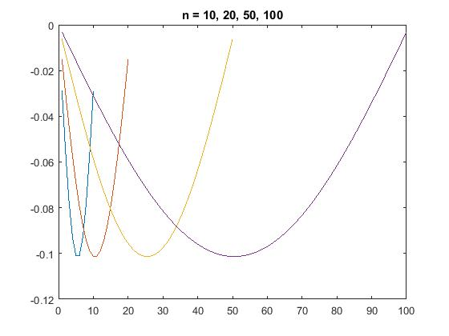Due to the limit of one page, left figure, fig1, is picking up the results of 10 and 20-dimension as references only. And right figure, fig2, plotted solutions of 10-D, 20-D, 50-D, and 100-D.

Plotted solution vector **x** for n = 10, 20, 50, 100

|  |  |  |  |
| --- | --- | --- | --- |
| [x] = matrix(10) | | [x] = matrix(20) | |
| x = |  | x = |  |
| -0.0287 |  | -0.0151 | -0.1012 |
| -0.0552 |  | -0.0299 | -0.099 |
| -0.0771 |  | -0.044 | -0.0945 |
| -0.0928 |  | -0.0572 | -0.0879 |
| -0.101 |  | -0.069 | -0.0794 |
| -0.101 |  | -0.0794 | -0.069 |
| -0.0928 |  | -0.0879 | -0.0572 |
| -0.0771 |  | -0.0945 | -0.044 |
| -0.0552 |  | -0.099 | -0.0299 |
| -0.0287 |  | -0.1012 | -0.0151 |

Grab few data as reference

**Prediction**

As we can see from the fig2, (1) its width trends to be larger, when n is becoming larger. (2) interval of solutions is fixed between -0.1 and 0. (3) the slopes of each set of solutions are going to be small. (4) all points are symmetric about their central pivot point. According to these features, it is apparently to conclude the connected plotted solutions will probably look like a ***very flat, nearly rectilinear parabola***, when n is going to be infinite. And the slope of it will trend to be zero.